Task6 | Walkthrough | sol

6.1

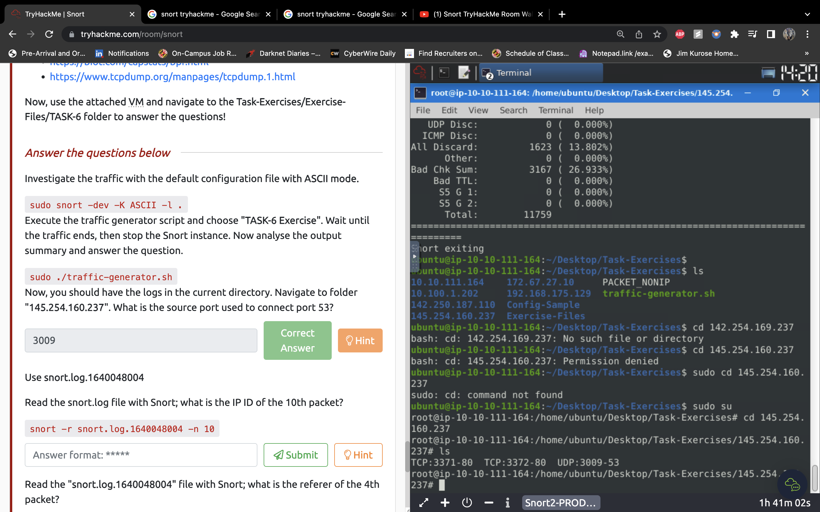



6.2

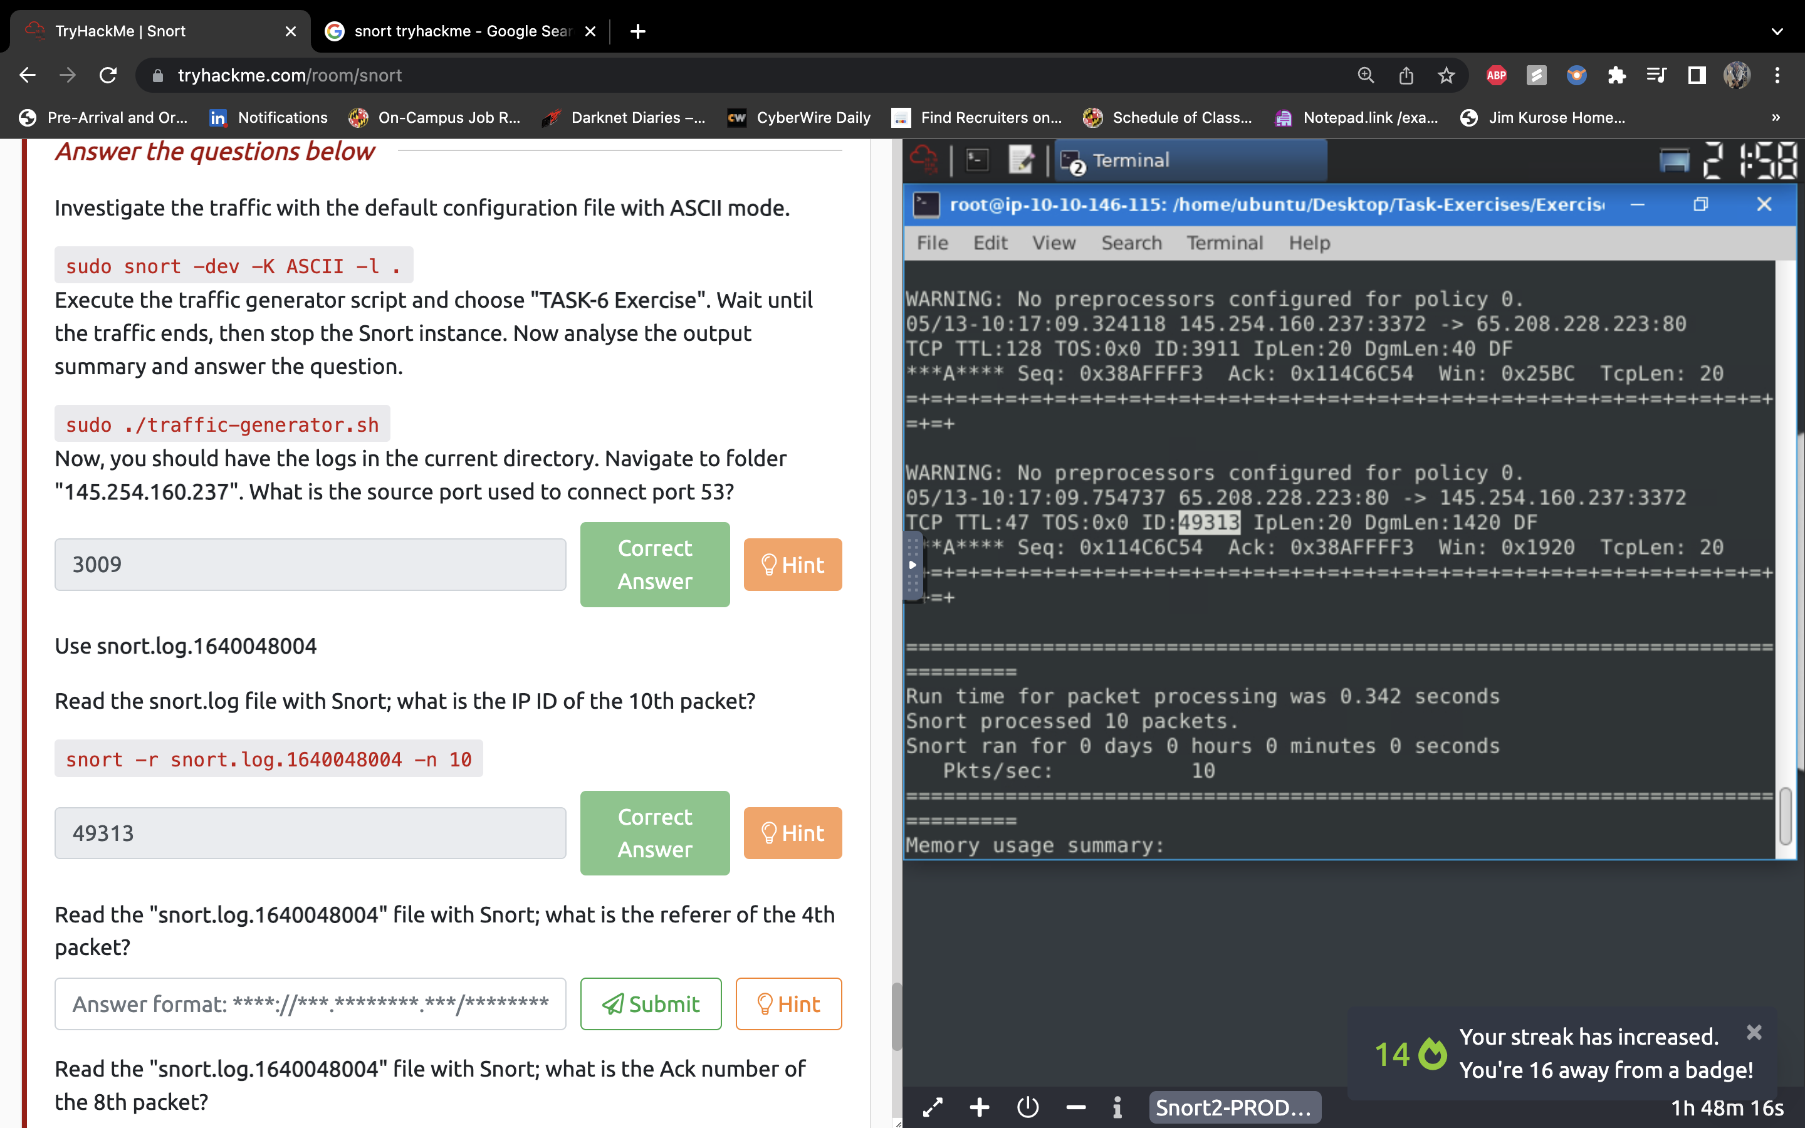

6.3 snort -d -r snort.log.1640048004 -n 4

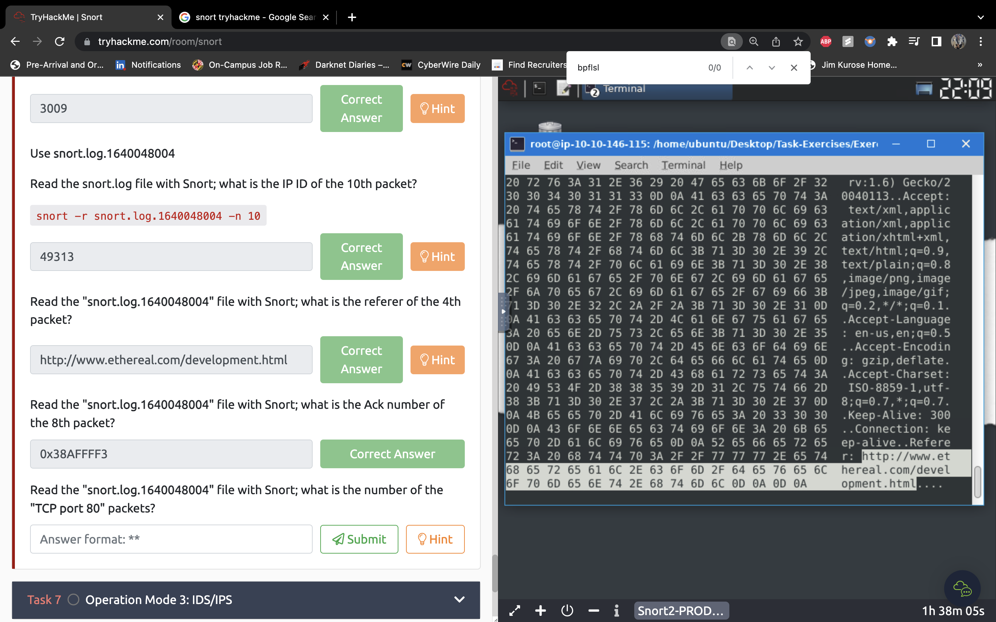

6.4 snort -r snort.log.1640048004 -n 8

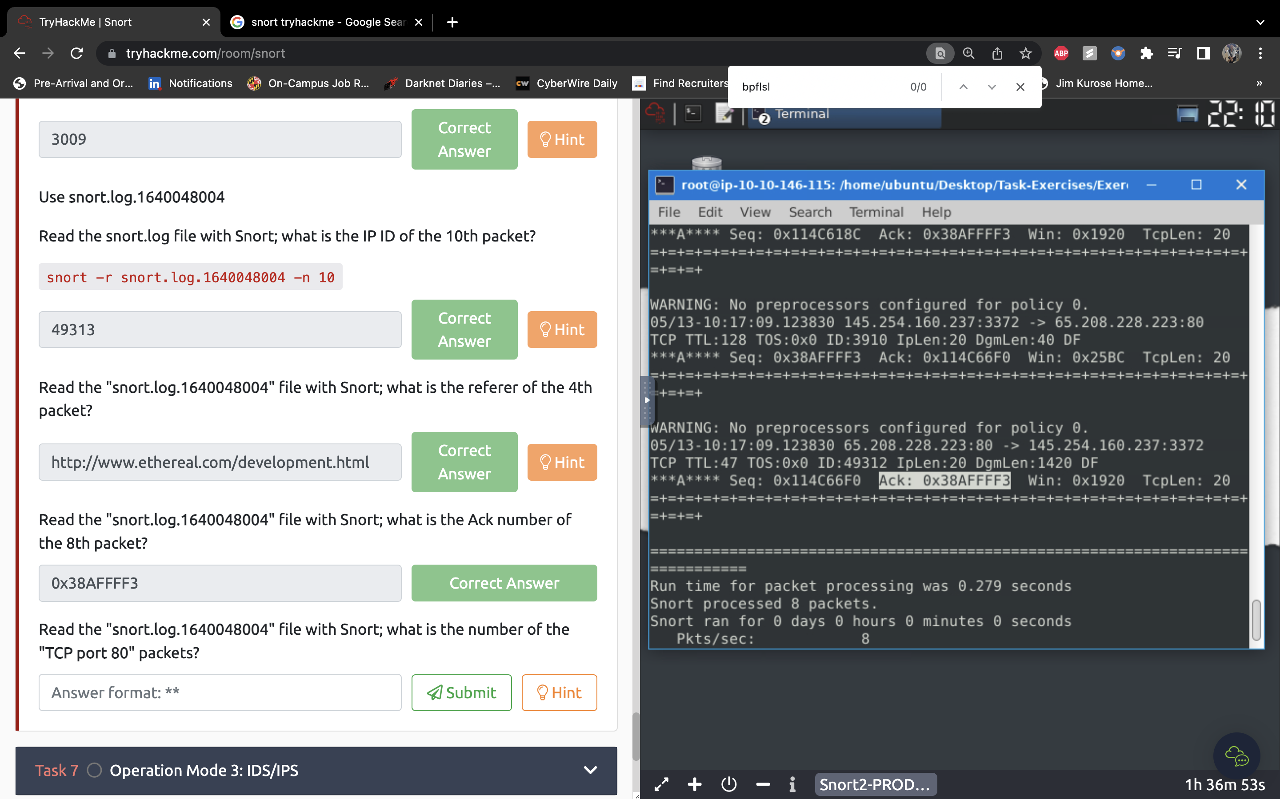

6.5 snort -r snort.log.1640048004 'tcp and port 80'

